SCHOOLOFCOMPUTER SCIENCE AND ARTIFICIAL INTELLIGENCE |  |  |  |  | DEPARTMENTOFCOMPUTER SCIENCE ENGINEERING
ProgramName:M. Tech/MCA |  |  |  | AssignmentType: Lab |  |  | AcademicYear:2025-2026
CourseCoordinatorName |  |  |  | Venkataramana Veeramsetty
CourseCode |  |  | 24CS002PC215 | CourseTitle |  | AI Assisted Problem Solving Using Python
Year/Sem |  |  | I/I | Regulation |  | R24
DateandDay  of Assignment |  |  | Week1 - Tuesday | Time(s)
Duration |  |  | 2 Hours | Applicableto  Batches |  | M. Tech/MCA
AssignmentNumber:03.3(Presentassignmentnumber)/24(Totalnumberofassignments)
 | Q.No. | Question |  |  |  |  |  | ExpectedTime  to complete

 | 1 | Application for TGNPDCL  Objective:Build an application using Python program for TGNPDCL, to generate the bill based on energy consumption and type of customer with the help of AI tools.  Build a python application as per below instructions  - Read all the required data like PU,CU and Type of customer  - Calculate bill amount based on number of units consumed, type of customer and othercharges  - Finally print the values of EC(Energy Charges),FC(Fixed Charges),CC(Customer Char-ges),ED(Electricity Duty Charges),bill as per expected output  Requirements:  - VS Code with Github Copilot and/or Google Colab with Gemini  - Students should bring power bill from their home  Deliverables:  - Print energy bill for given inputs and verify with bill taken by students  Prompt:  - Read all the required data like PU,CU and Type of customer · Calculate bill amount based on number of units consumed, type of customer and other charges · Finally print the values of EC(Energy Charges),FC(Fixed Charges),CC(Customer Char-ges),ED(Electricity Duty Charges),bill as per expected output  Code:  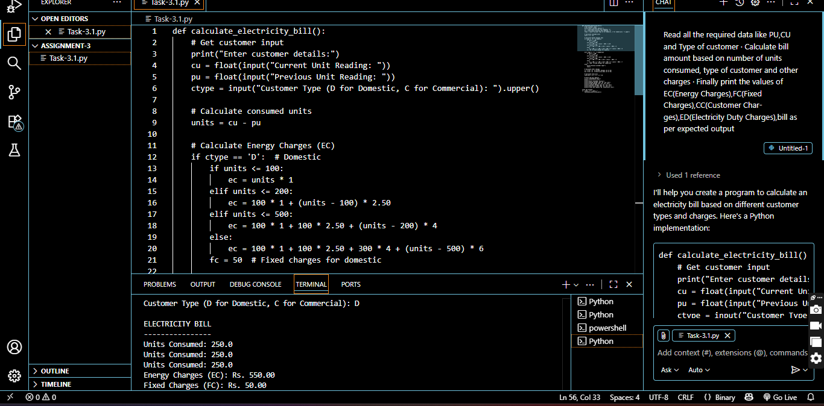  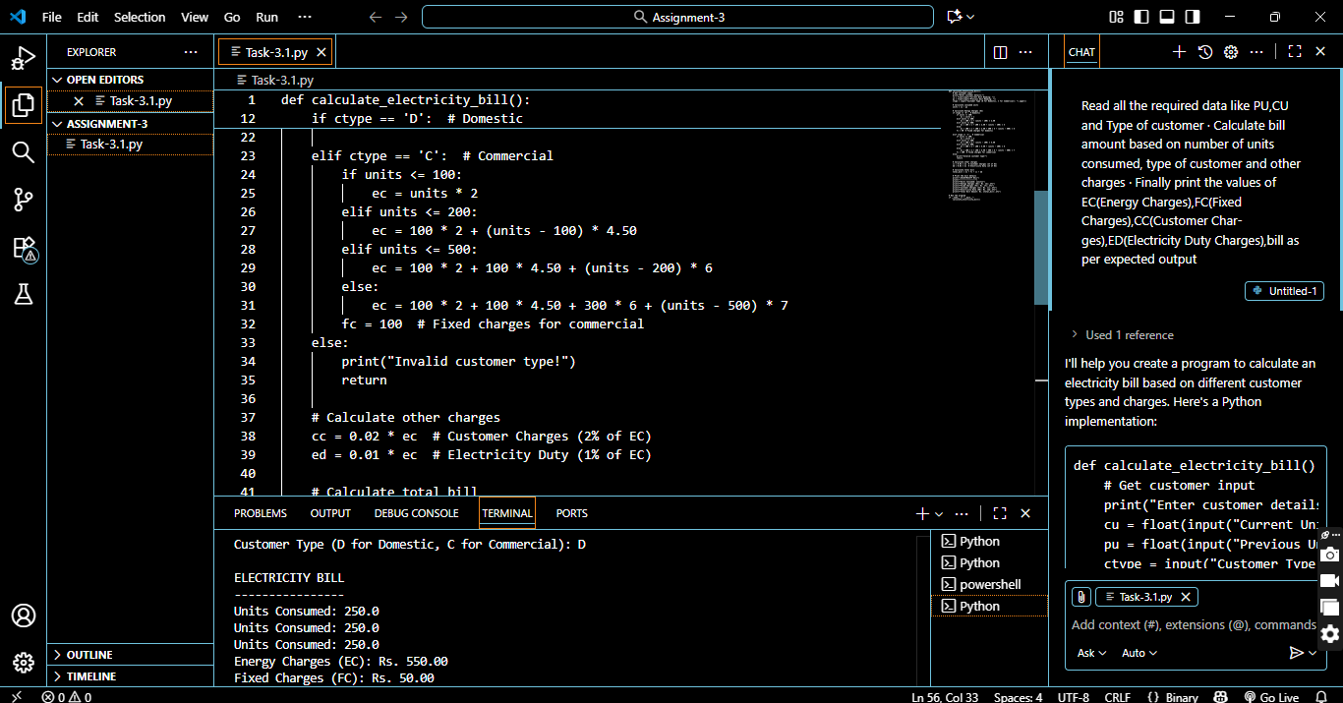  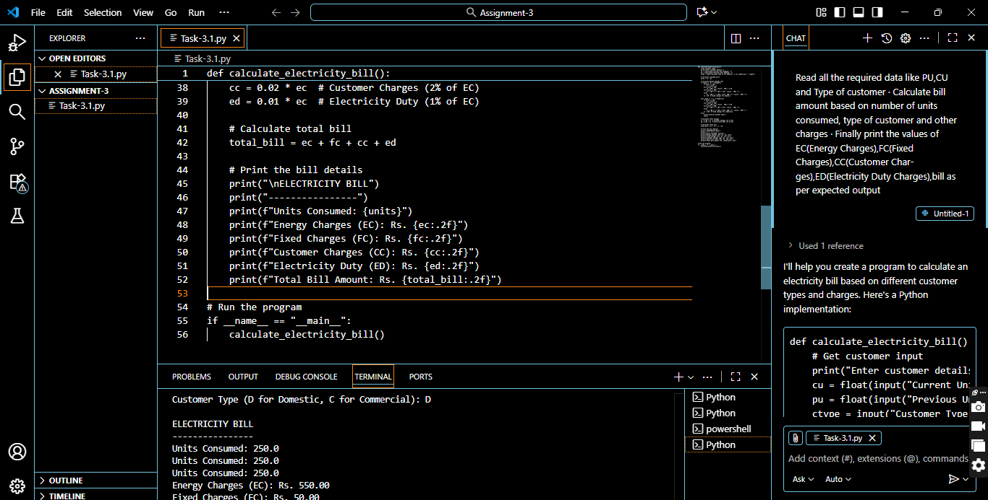  Output:  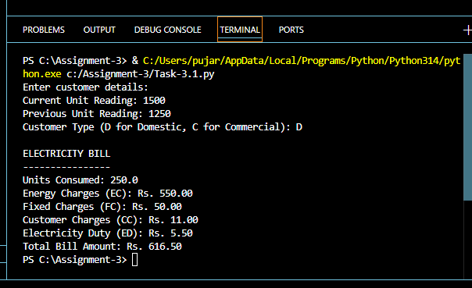 | Week2 – Wednesday

